Kunde KWT
ID: PBXd54a-d506-9f4d-4367-a634-a2db-0c6f-9538
Oxo Parameter:
IP Adresse: 192.168.20.240
Subnetmask:255.255.255.000
Gateway: 192.168.20.254
WebRTC GW IP: ???
Videoanleitung:
https://support.openrainbow.com/hc/de/articles/360003595240-Video-WebRTC-VM-Configuration-EN-
Konfiguration:
https://support.openrainbow.com/hc/de/articles/360001676490-VoIP-calling-Installation-guide-WebRTC-Gateway-

1.2 WebRTC gateway OVF/ISO installation:

1.2.1 Software Download
Since version 1.67 the SW package on ALE Portal contains the OVF files for a VMWARE installation and an ISO file for the installation on a standalone PC.
The WebRTC Gateway Software is subject to export control laws and you need to fill-in a web form to request the access to the software (detailed instructions are on the ALE Business Portal). Today the software is available under OXE R12.1, OXE 12.2, OXO Connect R3.0 and OXO Connect Evolution R3.0.

1.2.2 Installation:
First deploy the OVF file in your vCenter and start the virtual machine (VM) or if connected to an OXO Connect install the ISO file on a standalone PC (installation guide).
Note: The OVF and ISO have been created with a QWERTY keyboard, you may need to change it:
Login with following crendentials:
User=kb
Password=kb
The wizard to change the keyboard will be automatically started, just follow the instructions on the screen to change your keyboard.
You may also access to the same menu by using following commands:
# dpkg-reconfigure keyboard-configuration
# service keyboard-setup restart
For the configuration login with following credentials on the console:
User=rainbow
Password=Rainbow123
Make sure to change the default rainbow login password. Use the command passwd to change it.
For root commands you must use “sudo”

1.3 WebRTC Gateway configuration
When logged using rainbow account, the configuration is made using the commands mpnetwork [options...] and mpconfig [options...]
mphelp //displays the list of mpXXXXX commands//
mpstart|mpstop|mprestart //start, stop or restart gateway//
mpcheck //checks WebRTC gateway connectivity to Rainbow Cloud//
Note: you can find the mpnetwork and mpconfig commands in the history of the WebRTC gateway, that you can review using Up Arrow Key.

1.3.1 First Installation:
You need first to configure the Network settings then the WebRTC gateway settings.
By default the Rainbow WebRTC Gateway starts using a DHCP based network setting.
Login with the rainbow account to make the configuration.

1.3.1.1 Step 1 - Network configuration
Consult first What Are Rainbow Network Requirements?
The 1st time you have to run the command mpnetwork with the mandatory options IP, NETMASK, GATEWAY and DNS as shown below:
mpnetwork --IP="10.2.3.4" --NETMASK="255.255.255.0" --GATEWAY="10.2.3.254" --DNS="10.2.3.253"
You can also run for this 1st step the mpnetwork command with all options by adding NTP and HOSTNAME
mpnetwork --IP="10.2.3.4" --NETMASK="255.255.255.0" --GATEWAY="10.2.3.254" --DNS="10.2.3.253" --NTP="10.2.3.253" --HOSTNAME="rainbow-mpgw"
optional you can add following options
--HOSTDOMAIN="mycompany.com"
--PROXY="http://user:pass@10.2.3.252:8000/"
or
--PROXY="http://10.2.3.252:8000/"
In case you need to update the configuration each command can be executed separately
mpnetwork --IP="10.2.3.4" //your new ip address of the VM//
mpnetwork --NETMASK="255.255.255.0"
mpnetwork --GATEWAY="10.2.3.254" //your gateway//
mpnetwork --DNS="10.2.3.253" //your DNS//
mpnetwork --NTP="10.2.3.253"
mpnetwork --HOSTNAME="rainbow-mpgw"
mpnetwork --IP=dhcp //if you want to switch IP config to DHCP mode
you may also use
mpnetwork --FQDN="rainbow-mpgw.mycompany.com"
A summary of the changes is displayed and you are requested to confirm to apply those changes, then the WebRTC gateway will reboot automatically.

1.3.1.2 Step 2 - Configure the WebRTC Gateway:
The 1st time you have to run the command with the mandatory options PBX_DOMAIN and PBXID as shown below:
mpconfig --PBX_DOMAIN="10.2.3.5" --PBXID="PBXa1b1-2wxy-3c3d-6789-4e4f-g556-7h89-10i9"
PBX_DOMAIN= is your OXE/OXO ip address
PBXID= is your OXE/OXO pbxid in Rainbow
Since version 1.73.4-113 you can activate geolocalization for TURN servers.
With this new option the WebRTC gateway uses 2 TURN servers to establish the calls.
- In case of upgrade we recommend to run following command:
mpconfig --TURN_SERVER=GEOIP
- For a new installation the TURN option is default GEOIP.
A summary of the changes is displayed and you are requested to confirm to apply those changes, then the WebRTC gateway will reboot automatically.
optional you can use FQDN instead of IP Addresses
mpconfig --RAINBOW_DOMAIN="domain.yy.zz"
mpconfig --RAINBOW_HOST="host.uu.vv"
Note:
- PBX_DOMAIN can be an FQDN (in this case the DNS used by the WebRTC Gateway must resolve this FQDN)
- In case of spatial redundancy from OXE Call servers, the PBX_DOMAIN must contain the node name configured in netadmin, section 17. 'Node configuration'. This FQDN must be resolved by the DNS through a DNS delegation to the OXE system.
For WebRTC gateway version < 1.73 TURN Server is configured manually
mpconfig --TURN_SERVER="turn-abx.openrainbow.com"
mpconfig --TURN_PORT="3478" Choose the TURN server by replacing abx with the value of the TURN server that is the nearest to your location. List of TURN servers can be found in the document attached to the article What Are Rainbow Network Requirements?
Before 1.75.3, it is necessary to use mpapply command after changes in webRTC gateway configuration. This command will apply the modifications in the configuration files:
mpconfig --xxx
mpapply
mprestart

1.3.1.3 Step 3 - Check configuration
Once the server has restarted you can run the command mpcheck to check the connectivity to Rainbow Cloud.

1.3.1.4 Config files
Once you have executed both scripts mpnetwork and mpconfig you can check the configuration in following file /etc/rainbow-mp.cfg.
IP="10.2.3.4"
NETMASK="255.255.255.0"
GATEWAY="10.2.3.254"
HOSTNAME="rainbow-mpgw"
HOSTDOMAIN="mycompany.com"
DNS="10.2.3.253"
NTP="10.2.3.253"
LOGLEVEL="info"
JANUSLOGLEVEL="4"
PROXY=""
TURN_SERVER="turn-eu1.openrainbow.com"
TURN_PORT="3478"
PBXID="PBXa1b1-2wxy-3c3d-6789-4e4f-g556-7h89-10i9"
PBX_DOMAIN="10.2.3.5"
RAINBOW_DOMAIN="openrainbow.com"
RAINBOW_HOST="openrainbow.com"
This is a summary of the parameters that will be used to configure the VM and the 3 services of the WebRTC gateway.
/etc/janus/janus.cfg
/etc/otlitemediapillargateway/config.js
/etc/kamailio/kamctlrc

1.3.2.3 Change network settings to DHCP
run the command:
mpnetwork --IP=dhcp
optional you can add a proxy
mpnetwork --PROXY="user:pass@10.1.2.252:8000/"
After the modification reboot the server with the command sudo reboot

2 PBX Configuration

2.1 OminiPCX Enterprise configuration:
Please consult TC2462.

2.2 OXO Connect / OXO Connect Evolution
Please consult TC2479.

3 Rainbow Configuration:

3.1 Equipement configuration
For the OmniPCX Enterprise or OXO Connect connected to the WebRTC Gateway you'll have to select the option "Activate the WebRTC gateway"
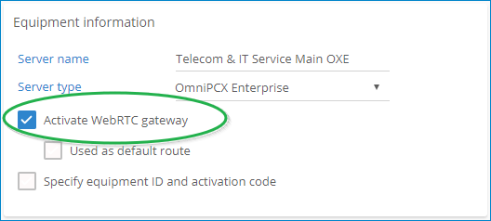

3.2 Users Configuration
Each user needs to be granted with either a Business or an Enterprise license
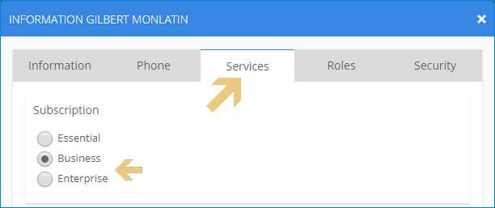
And the Rainbow account must be associated to his PBX phone
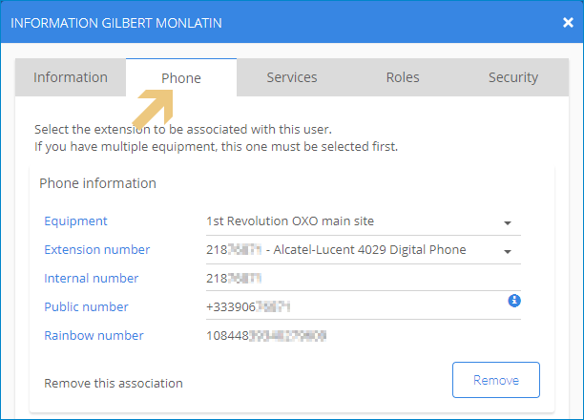

4 Troubleshooting:

